Setup Guide

To use the app, we need to create the database, as the app is using a local database.

1. Open Microsoft SQL Server Management Studio
2. Connect to server.

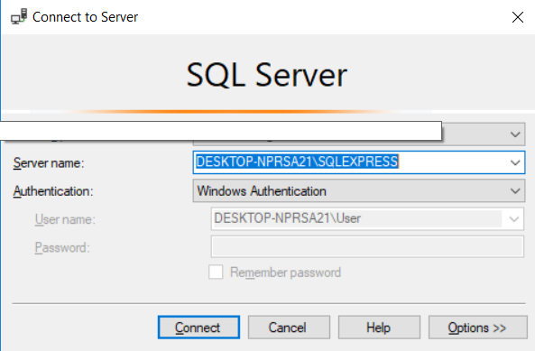

1. Right click on “Databases” and click on “New Database”.

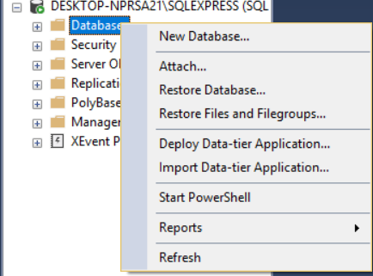

1. Enter database name - EventManagerDb.

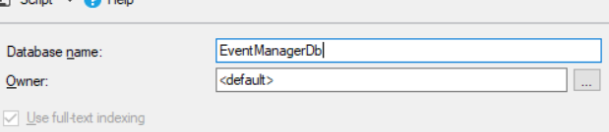

1. Right click on EventManagerDb and click on “New Query”

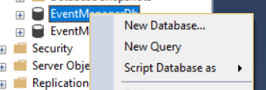

1. Paste the following query:

CREATE TABLE Event(

EventId int NOT NULL IDENTITY(1,1),

Name varchar(50),

Location varchar(50),

StartDateTime datetime,

EndDateTime datetime,

PRIMARY KEY (EventId)

);

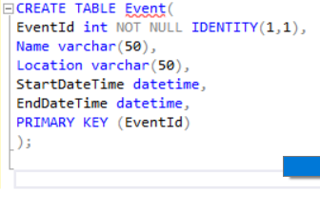

1. Press F5 in Object Explorer and then click on “Tables” to check if the new table Event is created

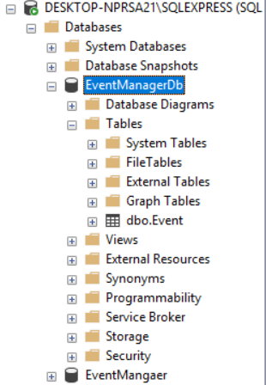

1. Open EventManager.sln from the folder.
2. Click on “Tools” and then “Connect to a Database”.

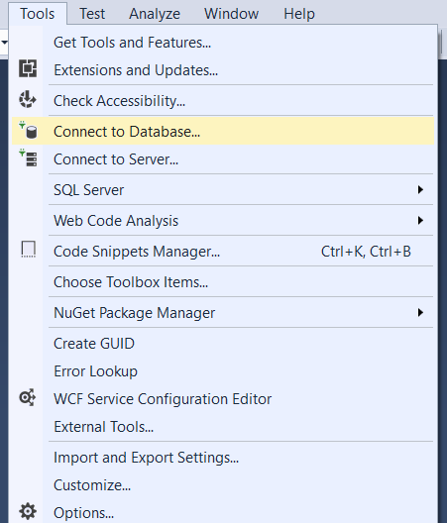

1. Go back to SQL Server Management Studio. Right click on “Properties” on the server and then copy the server’s name.

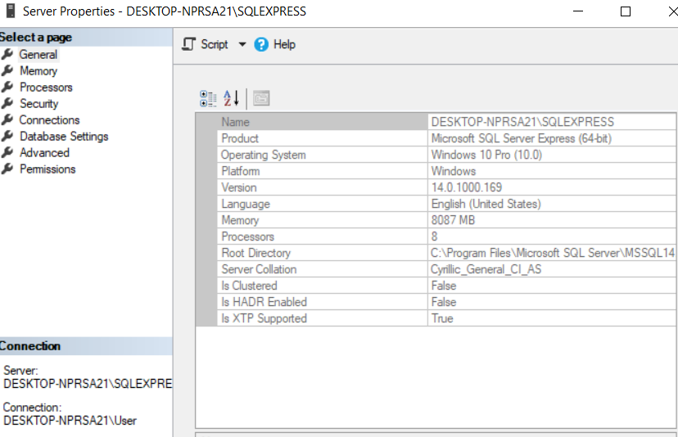

1. Paste it in the server name box in Visual Studio.
2. Select the database EventManagerDb and click on OK.

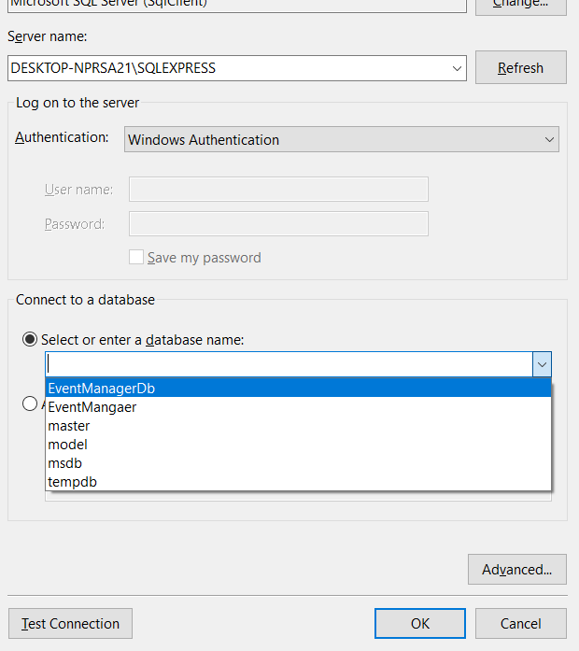

1. Start the app by pressing F5.